**Installing a Switch**

Student Version



Huawei Technologies Co., Ltd.

|  |
| --- |
| **Copyright © Huawei Technologies Co., Ltd. 2020. All rights reserved.**  No part of this document may be reproduced or transmitted in any form or by any means without prior written consent of Huawei Technologies Co., Ltd.  **Trademarks and Permissions**  HW_POS_RBG_Vertical-150ppi.png and other Huawei trademarks are trademarks of Huawei Technologies Co., Ltd.  All other trademarks and trade names mentioned in this document are the property of their respective holders.  **Notice**  The purchased products, services and features are stipulated by the contract made between Huawei and the customer. All or part of the products, services and features described in this document may not be within the purchase scope or the usage scope. Unless otherwise specified in the contract, all statements, information, and recommendations in this document are provided "AS IS" without warranties, guarantees or representations of any kind, either express or implied.  The information in this document is subject to change without notice. Every effort has been made in the preparation of this document to ensure accuracy of the contents, but all statements, information, and recommendations in this document do not constitute a warranty of any kind, express or implied. |

|  |  |
| --- | --- |
| Huawei Technologies Co., Ltd. | |
| Address: | Huawei Industrial Base  Bantian, Longgang  Shenzhen 518129  People's Republic of China |
| Website: | <https://e.huawei.com/> |

**Huawei Certification System**

Huawei Certification follows the "platform + ecosystem" development strategy, which is a new collaborative architecture of ICT infrastructure based on "Cloud-Pipe-Terminal". Huawei has set up a complete certification system consisting of three categories: ICT infrastructure certification, platform and service certification, and ICT vertical certification. It is the only certification system that covers all ICT technical fields in the industry. Huawei offers three levels of certification: Huawei Certified ICT Associate (HCIA), Huawei Certified ICT Professional (HCIP), and Huawei Certified ICT Expert (HCIE). Huawei Certification covers all ICT fields and adapts to the industry trend of ICT convergence. With its leading talent development system and certification standards, it is committed to fostering new ICT talent in the digital era, and building a sound ICT talent ecosystem.

Huawei Certified ICT Associate-Datacom (HCIA-Datacom) is designed for Huawei's frontline engineers and anyone who want to understand Huawei's datacom products and technologies. The HCIA-Datacom certification covers routing and switching principles, basic WLAN principles, network security basics, network management and O&M basics, SDN and programmability and automation basics.

The Huawei certification system introduces the industry, fosters innovation, and imparts cutting-edge datacom knowledge.



1. **Installing a Switch**
   1. **Background**

Installing switches is an important task in network system installation. This document uses a Huawei CloudEngine S5731-S series fixed switch as an example. Through this exercise, you will be able to understand the hardware structure of switches and know how to install them.

* 1. **Objectives**

Upon completion of this exercise, you will be able to:

* Recognize switches.
* Be familiar with the structure of Huawei switches.
* Install switches.
* Understand the precautions for installing a switch.
  1. **Planning**

This exercise helps you get familiar with switches and master how to install switches.

Prepare for installation: Learn about safety precautions, check whether the installation site, cabinet, and power supply system meet the installation requirements, and prepare installation tools and accessories.

Install a switch into a cabinet.

Install modules onto the switch, including power modules, cards, and optical modules.

Connect power cables, Ethernet cables, optical fibers, and copper cables to the switch.

Perform post-installation checks: Check whether the installation meets the requirements according to the installation checklist.

Power on the switch for the first time, and check whether the switch starts properly.

* 1. **Implementation**
     1. **Preparing for Installation**

Read safety precautions.

Before installing, operating, or maintaining a switch, read all safety regulations and precautions carefully and observe any warning labels affixed to the switch. Doing so ensures your safety and protects the switch from damage.

Check the installation site.

Read the installation guide carefully and confirm that the switch can be installed indoors or outdoors as required. Table 1-1 describes the requirements for the installation site.

Requirements for the installation site

| **Item** | **Requirement** |
| --- | --- |
| Cleanliness | The installation site must be clean, dry, well ventilated, and free from leaking or dripping water and dew. |
| Dust | The installation site must not have an excessive amount of dust. A buildup of dust may cause electrostatic discharge on the chassis and impair electrical connections, which will reduce the service life and may cause failure of the switch. |
| Temperature and humidity | The switch must be installed in a temperature-controlled environment where the temperature and humidity are within specifications. In environments where the relative humidity exceeds 70%, use dehumidifiers or dehumidifying air conditioners. |
| Corrosive gases | The installation site must be free from acidic, alkaline, or corrosive gases. |
| Airflow clearance | Leave at least 50 mm clearance around the switch for heat dissipation. |
| Service port surge protection | * If power and Ethernet cables of a switch need to be routed outdoors, bury them underground or put them in steel pipes to protect the switch from lightning strikes. * To protect network ports from lightning, use 8-line surge protectors. * When installing a network port surge protector, connect the IN end to terminals and the OUT end to network ports of the switch. * If fiber reinforcing ribs are used, ensure that they are properly grounded to protect the switches from lightning. |

Check the cabinet or rack.

Check whether the dimensions and grounding of the cabinet or rack meet the installation requirements. For details, see Table 1-2.

Requirements for the cabinet or rack

|  |  |
| --- | --- |
| **Item** | **Requirement** |
| Width | Use a standard 19-inch cabinet or rack. |
| Installation space | If you use a non-standard cabinet or rack, ensure that it has sufficient space for switch installation. |
| Grounding | The cabinet or rack must have reliable ground points for grounding the chassis. |
| Distance between front and rear mounting rails | Front and rear mounting brackets are required to install a switch into a cabinet. Ensure that the distance between front and rear mounting rails is within the specified range.  If the distance between front and rear mounting rails does not meet the requirement, use a pair of guide rails or a tray (prepared by the customer). |

Figure 1-1 shows the points from which to take measurements for the cabinet width (a), the cabinet depth (b), and the distance between front and rear mounting rails (c).

Measuring a cabinet

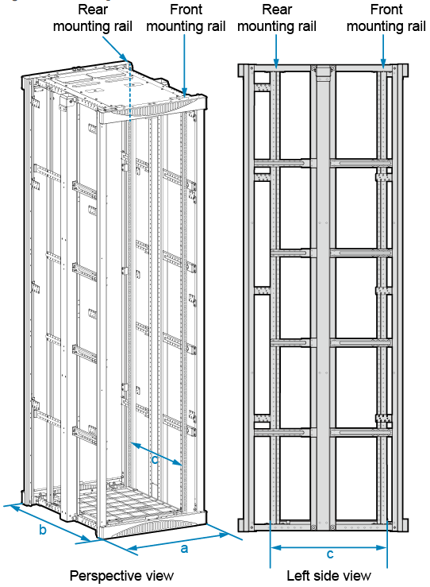

Check the power supply system.

The power supply system must be ready before the installation. Table 1-3 describes the requirements for the power supply system.

Power supply requirements

| **Item** | **Requirement** |
| --- | --- |
| Voltage | The input voltage must be within switch specifications.  Rated voltage range:   * AC input: 100 V AC to 240 V AC; 50/60 Hz * High-voltage DC input: 240 V DC * DC input: –48 V DC to –60 V DC   Maximum voltage range:   * AC input: 90 V AC to 290 V AC; 45 Hz to 65 Hz * High-voltage DC input: 190 V DC to 290 V DC * DC input: –38.4 V DC to –72 V DC |
| Power outlets and power cables | * To use AC power outlets, switches must have built-in AC power supply units or pluggable AC power modules, and use AC power cables complying with local standards. * To use an AC power distribution unit (PDU), switches must have built-in AC power supply units or pluggable AC power modules, and use C13 straight female to C14 straight male power cables. * To use a DC power distribution box, switches must have built-in DC power supply units or pluggable DC power modules, and use DC power cables. * The power cables and plugs delivered with a switch are for use with this switch only. Do not use them on other devices. |

Prepare installation tools and accessories.

Before installing a switch, prepare the following tools: ESD gloves, protective gloves, ESD wrist strap, utility knife, measuring tape, marker, flat-head screwdriver, Phillips screwdriver, diagonal pliers, Ethernet cable tester, multimeter, hammer drill, and adjustable wrench.

In addition, prepare the following auxiliary materials: cable tie, fiber binding tape, insulation tape, and corrugated pipe.

**----End**

* + 1. **Installing the Switch into the Cabinet**

Follow these precautions before or during the installation:

* Ensure that the cabinet is stable and meets the installation requirements.
* The switch installation position has been planned and arranged in the cabinet.
* The switch is placed near the cabinet and easy to move.
* Before the installation, take ESD measures, for example, wearing ESD gloves or an ESD wrist strap.
* When installing multiple switches in one cabinet or rack, leave at least 1 U (44.45 mm) between switches that use natural heat dissipation. For switches that use forced or intelligent air cooling, the recommended spacing between them is 1 U.
* Leave at least 50 mm clearance around the switch for heat dissipation.
* Align the mounting brackets on the left and right mounting rails. If they are not on a horizontal line, forcibly mounting the switch may distort the chassis.

Before the installation, prepare the following tools and accessories: ESD wrist strap or ESD gloves, Phillips screwdriver, flat-head screwdriver, floating nuts (four per switch, purchased separately), M4 screws, M6 screws (four per switch, purchased separately), front mounting brackets (two per switch), ground cable, and guide rails (optional).

The installation procedure is as follows:

Wear an ESD wrist strap or ESD gloves. When wearing an ESD wrist strap, ensure that it is in close contact with your wrist and grounded properly.

Use M4 screws to attach a front mounting bracket to each side of the switch.

Figure 1-2 shows the front mounting brackets that come with different switch models and the corresponding installation methods. The figure shows the installation methods of the left mounting brackets. The installation methods of the right mounting brackets are the same. See Figure 1-2 for the number of screws required for each mounting bracket.

Installing front mounting brackets

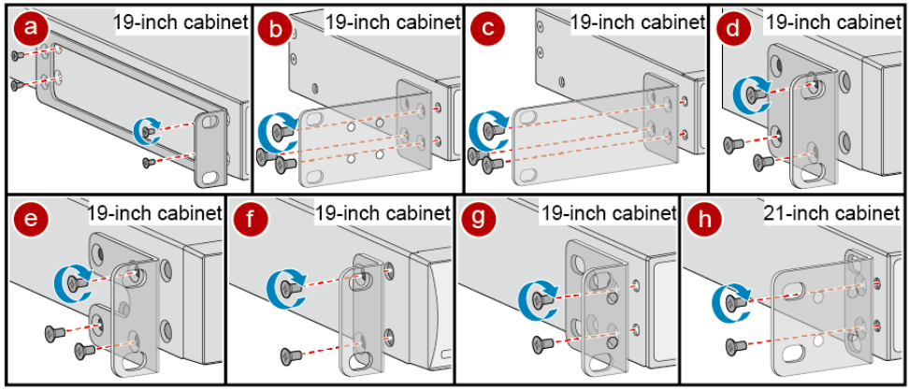

Connect the ground cable to the ground points of the switch and cabinet.

Use a Phillips screwdriver to remove the M4 screw from the ground point on the switch, as shown in Figure 1-3. Keep the M4 screw for later use.

Removing the M4 screw from the ground point on the switch

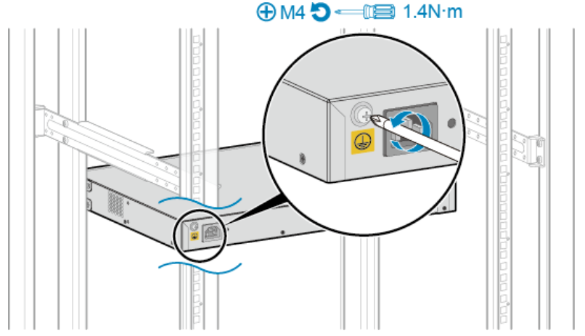

Attach the M4 lug of the ground cable to the ground point on the switch with the M4 screw you have removed. Tighten the M4 screw with a torque of 1.4 N•m. See Figure 1-4.

Connecting the ground cable to the ground point on the switch

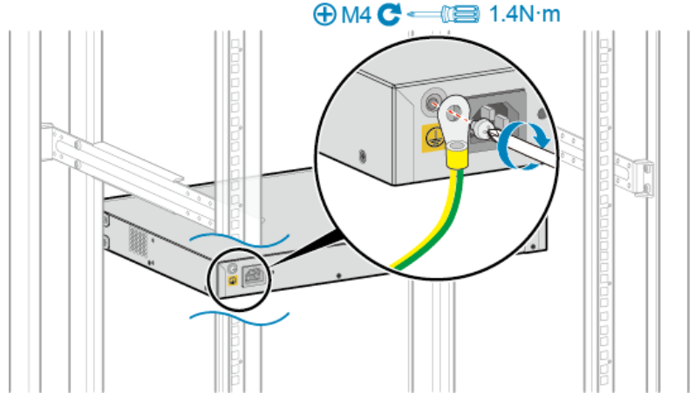

Attach the M6 lug of the ground cable to a ground point on the cabinet with an M6 screw. Tighten the M6 screw with a torque of 4.8 N•m. See Figure 1-5.

Connecting the ground cable to a ground point on the cabinet

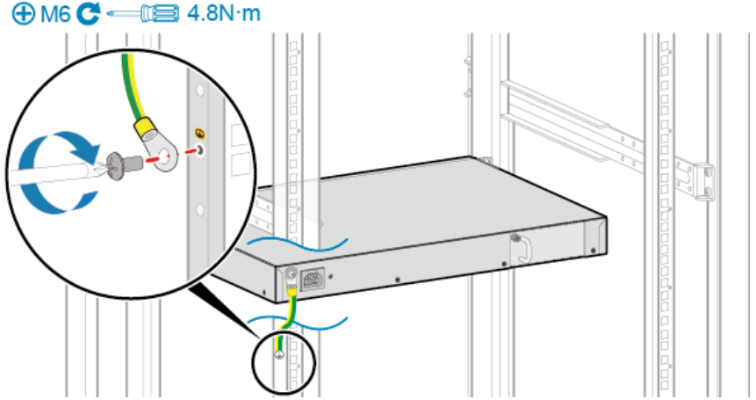

After the ground cable is connected, verify that the electrical resistance between the ground terminal and ground point on the switch is no more than 0.1 ohm on a multimeter.

Install floating nuts on the mounting rails of the cabinet.

Determine the installation position of the switch and use a flat-head screwdriver to install two floating nuts on each front mounting rail accordingly. Leave a gap of one mounting hole between the two floating nuts and ensure that they are level with those on the other rail. Pay attention to the scale markings on the mounting rails because three adjacent mounting holes may not be 1 U.

Install the switch into the cabinet.

The methods of installing switches in a cabinet using different front mounting brackets are the same. Figure 1-6 shows an example.

Hold the bottom of the switch and align the holes on the front mounting brackets with the floating nuts on the front mounting rails.

Secure the mounting brackets to the mounting rails with M6 screws (two on each side) using a Phillips screwdriver.

Installing the switch into the cabinet

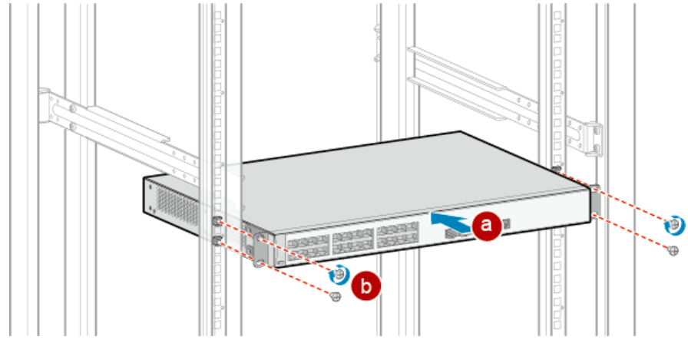

**----End**

* + 1. **Installing Modules**

After the switch is installed, install modules on the switch, including power modules, fan modules, cards, and optical modules.

* + - 1. **Installing a Pluggable Power Module and a Fan Module**

If a switch is delivered with power modules and fan modules installed in the chassis, you do not need to install them again. The methods of installing a fan module and a power module are the same. Fan modules and power modules are both classified into two types: one type is secured by a captive screw and the other is secured by a latch. A power module is used as an example here to describe the installation procedure.

Before the installation, prepare an ESD wrist strap or ESD gloves, as well as a Phillips screwdriver.

The installation procedure is as follows:

Wear an ESD wrist strap or ESD gloves. When wearing an ESD wrist strap, ensure that it is in close contact with your wrist and grounded properly.

Remove the filler panel from the slot where a power module is to be installed. Keep the filler panel for future use.

A filler panel can be secured by a captive screw or a latch.

* To remove a filler panel secured by a captive screw, perform the following steps:

Use a Phillips screwdriver to loosen the captive screw on the filler panel counterclockwise.

Pull the filler panel out by the captive screw.

Removing a filler panel secured by a captive screw

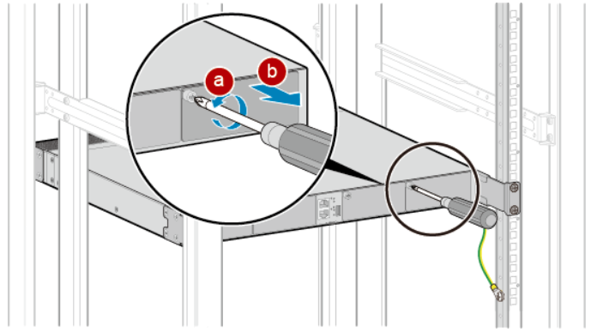

* To remove a filler panel secured by a latch, perform the following steps:

Press and hold the latch on the filler panel rightward with your thumb.

Pull the filler panel out by the handle.

Removing a filler panel secured by a latch

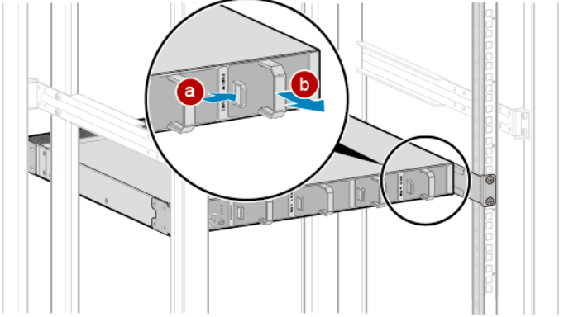

Install a power module.

* To install a power module secured by a captive screw, perform the following steps:

Hold the handle on the power module with one hand and support the bottom with the other hand. Horizontally push the power module into the slot until it is completely in the slot.

Use the Phillips screwdriver to fasten the captive screw on the power module clockwise.

Installing a power module secured by a captive screw

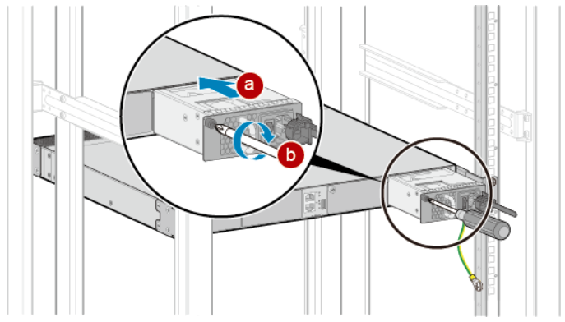

* To install a power module secured by a latch, hold the handle of the power module with one hand, support the bottom with the other hand, and horizontally push the power module into the slot, as shown in Figure 1-10. When the power module is completely seated in the slot, the latch is locked automatically.

Installing a power module secured by a latch

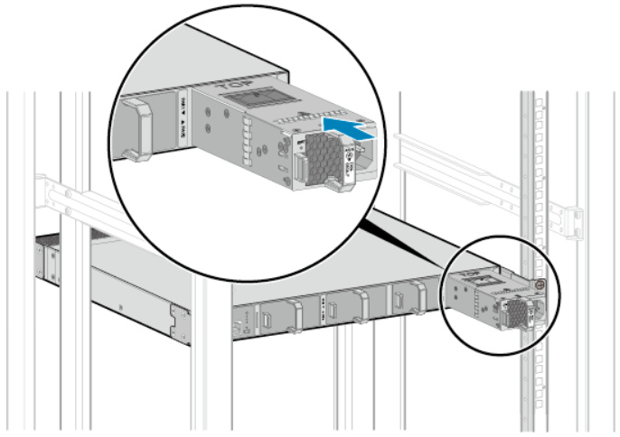

**----End**

* + - 1. **Installing Cards**

Some switch models support pluggable cards. Different pluggable cards are installed in the same way. A 4-port front card is used as an example here to describe the installation procedure.

Before the installation, prepare an ESD wrist strap or ESD gloves, as well as a Phillips screwdriver.

The installation procedure is as follows:

Wear an ESD wrist strap or ESD gloves. When wearing an ESD wrist strap, ensure that it is in close contact with your wrist and grounded properly.

Remove the filler panel from the slot where the card is to be installed. Keep the filler panel for future use.

Use a Phillips screwdriver to loosen the captive screw on the filler panel counterclockwise.

Pull the filler panel out by the captive screw.

Install the card into the switch.

Pull the ejector lever of the card 45 degrees outward. Gently push the card into the chassis with your thumbs placed below the captive screws, until the screw on the front panel is completely in the chassis.

Push the ejector lever inward to lock the card.

Use a Phillips screwdriver to tighten the captive screws.

**----End**

* + - 1. **Installing Optical Modules**

Before the installation, prepare an ESD wrist strap or ESD gloves.

The installation procedure is as follows:

Wear an ESD wrist strap or ESD gloves. When wearing an ESD wrist strap, ensure that it is in close contact with your wrist and grounded properly.

Remove the dust plug from an optical port. Keep the dust plug for future use.

Ensure that the optical module is correctly oriented, and gently push it into the optical port until you hear a click.

If the optical module cannot be completely inserted into the optical port, do not force it into the port. Turn the optical module 180 degrees and try again.

Check whether the optical module is securely seated. While keeping the handle of the optical module closed, grasp the two sides of the optical module with your thumb and forefinger and gently pull it.

* If the optical module does not pull out, it is installed correctly.
* If the optical module pulls out, reinstall it.

**----End**

* + 1. **Connecting the Switch**
       1. **Connecting Power Cables**

Fixed switches support built-in power supply units, pluggable power modules, and independent power modules. The required power cables and their connection methods vary according to the power modules used on switches. The following procedure applies to built-in AC power supply units and AC power modules.

Before the installation, prepare an ESD wrist strap or ESD gloves, as well as an AC power cable locking strap (optional).

The installation procedure is as follows:

Wear an ESD wrist strap or ESD gloves. When wearing an ESD wrist strap, ensure that it is in close contact with your wrist and grounded properly.

Turn off the external power supply system for the switch.

Turn off the power switch on the switch or power module.

Skip this step if there is no power switch on the switch or power module.

Connect a power cable to the switch or power module.

This following uses a built-in AC power supply unit as an example to describe how to connect an AC power cable.

(Optional) Install the AC power cable locking strap.

Insert the AC power cable plug into the power socket on the switch or AC power module, as shown in Figure 1-11.

Connecting the AC power cable plug

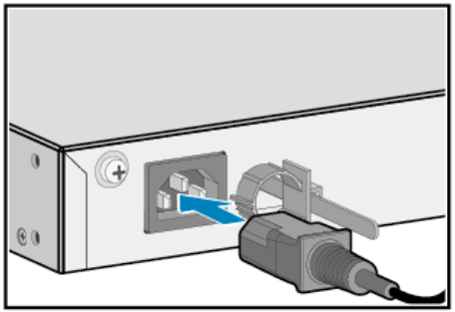

(Optional) If an AC power cable locking strap is installed, adjust its size to fit the AC power cable plug.

**----End**

* + - 1. **Connecting Ethernet Cables**

After the power module is connected, connect an Ethernet cable to the switch. Note the following points:

* Before deploying Ethernet cables, test their continuity.
* If Ethernet cables of the switch need to be routed outdoors, bury them underground or put them through steel pipes to avoid lightning strikes to the switch. Do not aerially route Ethernet cables outdoors.
* Keep signal cables more than 10 cm away from power cables.

If a switch does not support or use a rear card, the Ethernet cables used on its electrical ports and the distance between the switch front panel and cabinet front door must meet the requirements described in Table 1-4.

Requirements for Ethernet cables

|  |  |
| --- | --- |
| **Ethernet Cable Type** | **Distance (Excluding the Length of a Copper Module) Between the Switch Front Panel and Cabinet Front Door (X)** |
| Category 5 unshielded twisted pair | X ≥ 80 mm  For a switch with 48 electrical ports, route Ethernet cables from both sides of the cabinet. |
| Category 5 shielded twisted pair | X ≥ 110 mm  For a switch with 48 electrical ports, route Ethernet cables from both sides of the cabinet. |
| Category 6 twisted pair | X ≥ 120 mm  For a switch with 48 electrical ports, route Ethernet cables from both sides of the cabinet. |

When a switch has a rear card installed:

* In a cabinet deeper than 600 mm, the Ethernet cables used on its electrical ports and the distance between the switch front panel and cabinet front door must meet the requirements described in Table 1-4. There is no specific requirement for the distance between the switch rear panel and cabinet rear door.
* In a 600 mm deep cabinet, the Ethernet cables used on its electrical ports, the optical fibers used on the rear card, and the distances between the switch panels and cabinet doors must meet the requirements described in Table 1-5.

Requirements for Ethernet cables and optical fibers

| **Ethernet Cable Type** | **Distance (Excluding the Length of a Copper Module) Between the Switch Front Panel and Cabinet Front Door (X)** | **Distance Between the Switch Rear Panel and Cabinet Rear Door (Y)** | | |
| --- | --- | --- | --- | --- |
| **Ultra-short Pigtail** | **Short Pigtail** | **Regular Fiber or QSFP+ Fiber** |
| Category 5 unshielded twisted pair | 80 mm < X < 100 mm | Y ≥ 60 mm | Y ≥ 72 mm | Y ≥ 80 mm |
| Category 5 shielded twisted pair | X = 110 mm | Y ≥ 60 mm  Route Ethernet cables from both sides of the cabinet. | Y ≥ 72 mm  Route Ethernet cables from both sides of the cabinet. | Cannot be used together with category 5 shielded twisted pair Ethernet cables. |
| Category 6 twisted pair | X = 120 mm | Y ≥ 60 mm  Route Ethernet cables from both sides of the cabinet. | Cannot be used together with Category 6 twisted pair Ethernet cables. | Cannot be used together with category 6 twisted pair Ethernet cables. |

Before the installation, prepare an ESD wrist strap or ESD gloves, diagonal pliers, cable ties, marker, and Ethernet cable labels.

The installation procedure is as follows:

Determine the number and type of ports to be connected and plan the cabling routes.

Obtain the desired quantity and lengths of Ethernet cables.

Attach temporary labels to both ends of each Ethernet cable and number them corresponding to port numbers.

Route the Ethernet cables, arrange the cables in the cabinet, and then install cable connectors. Cable connectors made onsite must be securely attached and comply with related standards.

Wear an ESD wrist strap or ESD gloves. When wearing an ESD wrist strap, ensure that it is in close contact with your wrist and grounded properly.

Connect the cable connectors to the ports, matching the numbers on the Ethernet cables to those on the ports. After connecting the cables, verify that they are all correctly connected.

Arrange the Ethernet cables so that they are parallel, and then bundle them with cable ties loosely according to Table 1-6. Use diagonal pliers to cut off redundant cable ties. The use of protective pads under the cable ties is recommended, as shown in Figure 1-12. A bundle cannot have more than 24 cables. A bundle of no more than 12 cables is recommended.

Spacing between cable ties

|  |  |
| --- | --- |
| **Diameter of a Bundle** | **Spacing Between Cable Ties** |
| < 10 mm | 150 mm |
| 10–30 mm | 200 mm |
| > 30 mm | 300 mm |

Binding Ethernet cables

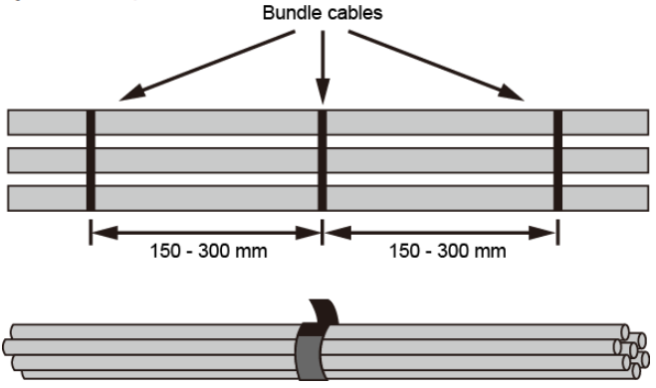

Replace all temporary labels on the Ethernet cables with permanent labels.

**----End**

* + - 1. **Connecting Optical Fibers**

Note the following when connecting optical fibers:

* Before deploying optical fibers, test their continuity.
* Keep optical fibers more than 10 cm away from power cables.
* Use corrugated pipes to protect optical fibers routed in a cabinet or rack. The bend radius of an optical fiber must be at least 20 times greater than its diameter. Generally, the bend radius of optical fibers is at least 40 mm.
* Fiber connectors must be tidy and clean to ensure normal communication. If a fiber connector is contaminated, clean it with fiber cleaning paper.

Before the installation, prepare an ESD wrist strap or ESD gloves, corrugated pipe, fiber binding strap, marker, and engineering labels.

The installation procedure is as follows:

Determine the number and type of ports to be connected and plan the cabling routes.

Obtain the desired types, quantity, and lengths of optical fibers.

Wear an ESD wrist strap or ESD gloves. When wearing an ESD wrist strap, ensure that it is in close contact with your wrist and grounded properly.

Attach temporary labels to both ends of each optical fiber and number them corresponding to port numbers.

Remove the dust plugs from optical modules and the dust caps from the optical fibers to be connected.

Connect optical fibers to the optical modules on the switch, matching the numbers on the optical fibers to those on the ports. To connect them, align the fiber connector with the bores on the optical module and insert the fiber connector. When you hear a click, the fiber connector is securely connected. See Figure 1-13. Connect the receive and transmit ends of a fiber connector to the receive and transmit bores of the optical module.

Connecting optical fibers to an optical module

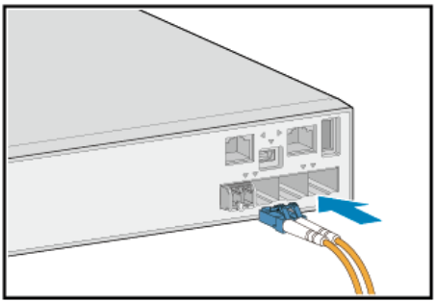

Arrange the optical fibers to make them parallel and bundle them with fiber binding tape at a spacing of 150–300 mm.

Replace all temporary labels on the optical fibers with permanent labels.

**----End**

* + - 1. **Connecting Copper Cables**

Note the following when connecting copper cables:

* Both ends of an idle copper cable must be covered by an ESD cap.
* Do not bend copper cables over their minimum bend radius. Doing so may damage wires in the cables.
* Connectors of copper cables must be clean to ensure normal communication. If a connector is contaminated, clean it with cable cleaning paper.
* Ensure that the bend radius of the copper cables or optical fibers is greater than the minimum bend radius required. For specific bend radiuses of various cables, see the product documentation.

Before the installation, prepare an ESD wrist strap or ESD gloves, diagonal pliers, cable ties, a marker, and copper cable labels.

The installation procedure is as follows:

Determine the number and type of ports to be connected and plan the cabling routes.

Obtain the desired quantity and lengths of copper cables.

Wear an ESD wrist strap or ESD gloves. When wearing an ESD wrist strap, ensure that it is in close contact with your wrist and grounded properly.

Attach temporary labels to both ends of each copper cable and number them corresponding to port numbers.

Connect the copper cables to ports on the switch, matching the numbers on the copper cables to those on the ports. To connect them, align the copper cable connector with the port and insert the connector. When you hear a click, the copper cable is securely connected. See Figure 1-14.

Connecting a copper cable

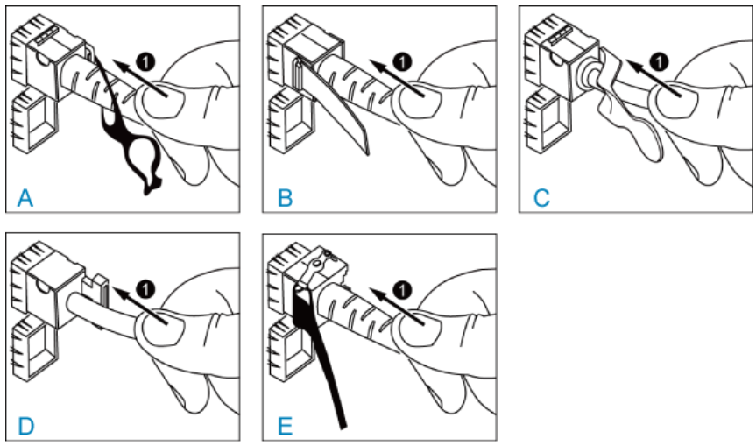

To remove a copper cable, gently push the cable connector inward and then pull the handle of the connector. Do not forcibly pull the cable connector. See Figure 1-15.

Removing a copper cable

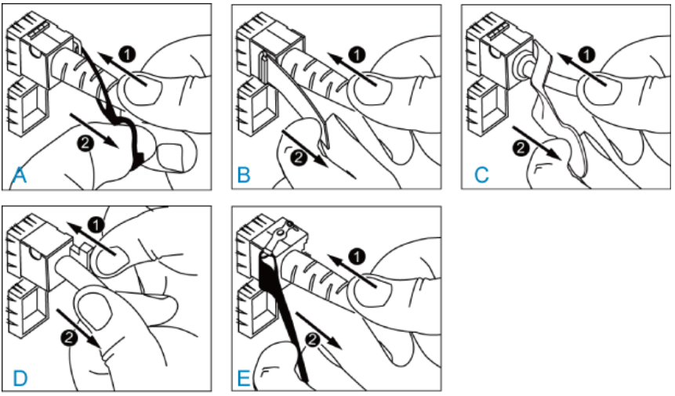

Arrange the copper cables to make them parallel, and bundle them with cable ties at a spacing of 150–300 mm. Use diagonal pliers to cut off redundant cable ties.

Replace all the temporary labels on the copper cables with permanent labels.

**----End**

* + 1. **Performing Post-installation Checks**

Post-installation checklist

| **No.** | **Check Item** | **Check Method** |
| --- | --- | --- |
| 1 | The installation position of the switch meets the requirement in the associated engineering design document. | Observe |
| 2 | The surfaces of the switch are clean and smooth, free from fingerprints, stains, and scratches. | Observe |
| 3 | Components are correctly installed in the cabinet. No component is loose or damaged. | Observe |
| 4 | All screws are correctly tightened. | Observe |
| 5 | There are no objects on the chassis. | Observe |
| 6 | Leave at least 50 mm clearance on the left and right sides of the switch for heat dissipation. | Measure |
| 7 | Signal cables are not damaged or broken and have no splices. | Observe |
| 8 | Signal cable connectors are clean, intact, and correctly connected. Wires of each signal cable are securely clamped in the connectors. | Observe |
| 9 | Each signal cable has labels attached at both ends, with clear text facing the same direction. | Observe |
| 10 | The power cables and ground cable are all copper wires, and are not spliced or damaged. | Observe |
| 11 | The power cables and ground cable are routed in compliance with the associated engineering design document and meet the power distribution requirements. | Observe |
| 12 | The power cables and ground cable are securely connected in compliance with regulations. Ground cable lugs are protected with spring washers on flat washers. | Observe |
| 13 | The power cables and ground cable are separated from the signal cables. | Observe |
| 14 | The power cables and ground cable are routed straightly and bundled neatly. Sufficient slack is left at the bent part of the cables. | Observe |
| 15 | Optical fibers routed out of the cabinet are protected. For example, they are routed in a corrugated pipe or trough. | Observe |
| 16 | The bend radius of optical fibers is 20 times larger than their diameter. Generally, the bend radius is greater than 40 mm. | Measure |
| 17 | Optical fibers are bundled neatly using binding tape with suitable force. | Observe |
| 18 | No signal cables are routed near the heat vents on the cabinet. | Observe |
| 19 | Cables in the cabinet do not cross each other and cables outside the cabinet are bundled. | Observe |

* + 1. **Powering On the Switch for the First Time**

Before powering on the switch, prepare an ESD wrist strap or ESD gloves, a multimeter, and a console cable.

Perform the following checks before powering on a switch:

Use a multimeter to check that there is no short-circuit condition between the phase wire (live wire), ground wire, and neutral wire in each power outlet.

Use the multimeter to check that the input voltage provided by the external power supply system is within the operating voltage range for the switch.

Check that the power switches of the external power supply system and the switch or the power module are both turned off.

Check that the power cables are correctly connected.

Wear an ESD wrist strap or ESD gloves. When wearing an ESD wrist strap, ensure that it is in close contact with your wrist and grounded properly.

Connect the DB-9 connector of the console cable to the 9-pin serial port on a maintenance terminal. Then, connect the RJ45 connector of the console cable to the console port on the switch.

Turn on the external power supply system connected to the switch.

Turn on the power switch on the switch or power module.

Skip this step if the switch does not support pluggable power modules or does not have a power switch.

After the switch completes its startup, check the indicators on the switch and power modules.

The SYS indicator on the switch and the STATUS indicators on the fan modules and power modules should be steady green.

**----End**

* 1. **Project Result Records**

Record the check results in Table 1-7.

Fill in Table 1-8 with the pre-power-on check results.

Check items before the initial power-on

|  |  |  |
| --- | --- | --- |
| **No.** | **Check Item** | **Check Result** |
| 1 | Use a multimeter to check whether there is any short-circuit condition between the phase wire (live wire), ground wire, and neutral wire in each power outlet. |  |
| 2 | Use a multimeter to check whether the input voltage provided by the external power supply system is within the operating voltage range for the switch. |  |
| 3 | Check whether the power switches of the external power supply system and the switch or the power module are both off. |  |
| 4 | Check whether the power cables are correctly connected. |  |
| 5 | Check whether the indicators on the switch and power modules are in normal state. |  |

**----End**